Directions
- Carefully read the overhead projection for any additional directions specific to this quiz/exam.
- In the header, replace the highlighted text with your name and remove the highlight.
- Make your final answers clear, ideally with circles or in green. Correct answers made clear “after the fact” will not be graded.

- Any questions with an answer but no justifying work will be graded as incorrect.

- (Exceptions are made for those with accommodations requests.)
>>>>>> ALL TEXT OR OTHER FORMS OF ANSWERS WILL BE IGNORED!!!!!!!! <<<<<<<
>>>>>> THIS INCLUDES POWERPOINT AND OTHER VECTORIZED DRAWINGS !!!!! <<<<
X
- Violating any of these rules or other malicious behavior will result in a 0 grade and disciplinary action report to the provost’s office.
- Partial credit is awarded for flawed work or answering the question outside of given constraints: do not leave an answer blank if you can answer a similar question.
- Any indication of copied work, especially identical incorrect answers or identically formatted answers will 1) be marked as incorrect and 2) be referred to the Provost’s Office for academic misconduct.
- Submit your final answers as a PDF document by the deadline.

 | Expression | Dual
P2 | $$a+0=a$$ | $$a⋅1=a$$
P3 | $$a+b=b+a$$ | $$ab=ba$$
P4 | $$a+\left(b+c\right)=\left(a+b\right)+c$$ | $$a\left(bc\right)=\left(ab\right)c$$
P5 | $$a+bc=(a+b)(a+c)$$ | $$a\left(b+c\right)=ab+ac$$
P6 | $$a+\overline{a}=1$$ | $$a⋅\overline{a}=0$$
T1 | $$a+a=a$$ | $$a⋅a=a$$
T2 | $$a+1=1$$ | $$a⋅0=0$$
T3 | $$\overline{\overline{a}}=a$$
T4 | $$a+ab=a$$ | $$a\left(a+b\right)=a$$
T5 | $$a+\overline{a}b=a+b$$ | $$a\left(\overline{a}+b\right)=ab$$
T6 | $$ab+a\overline{b}=a$$ | $$\left(a+b\right)\left(a+\overline{b}\right)=a$$
T7 | $$ab+a\overline{b}c=ab+ac$$ | $$\left(a+b\right)\left(a+\overline{b}+c\right)=(a+b)(a+c)$$
T8 | $$\overline{a+b}=\overline{a}\overline{b}$$ | $$\overline{ab}=\overline{a}+\overline{b}$$
T9 | $$ab+\overline{a}c+bc=ab+\overline{a}c$$ | $$\left(a+b\right)\left(\overline{a}+c\right)\left(b+c\right)=(a+b)(\overline{a}+c)$$
T10(a) | $$f\left(x_{1},x_{2},…,x_{n}\right)=x_{1}⋅(f\left(1,x_{2},…,x_{n}\right)+\overline{x_{1}}⋅f(0,x_{2},…,x_{n})$$
T10(b) | $$f\left(x_{1},x_{2},…,x_{n}\right)=\left[x_{1}+f\left(0,x_{2},…,x_{n}\right)\right]\left[\overline{x_{1}}+f\left(1,x_{2},…,x_{n}\right)\right]$$
This page is intentionally left blank: you may use it as scratch “paper”.

Problem 1 (2.5 points)
Minimize the following function using K-maps into its minimal sum-of-products form.
$$f\left(a,b,c,d\right)=a\overline{b}cd+\overline{b}\overline{c}d+ab\overline{c}+\overline{a}b\overline{d}+\overline{a}b\overline{c}d$$

Problem 2 (2.5 points)
Make the following function using the minimum number of NOR gates.
$$f\left(A,B,C,D\right)=∏\left(0,1,2,6,7,10\right)⋅D\left(3,8,9,14\right)$$

Problem 3 (2.5 points)
Convert the following circuit into one using only NOR gates (and no inverters). Do not optimize the circuit except for the number of “inverters”.
$$F$$
$$B$$
$$C$$
$$A$$

Problem 4 (2.5 points)
Create a 2-to-3 active-low decoder with an active-low enable. Name your inputs $\{x_{2},x_{1}, x_{0}, \overline{E}\}$ (with $x_{0}$ as the LSB).

Problem 5 (4 points)
Design a 4-to-16 active-low decoder using only 2-to-4 active-low decoder modules. No other gate types or modules may be used (you may use constant values). Assume that each 2-to-4 decoder has one active-low enable input, $\overline{E}$. Name your 4-to16 decoder inputs $\{x_{3},x_{2},x_{1},x_{0}\}$ with $x_{3}$ being the MSB.

Problem 6 (3 points)
Realize the expression $Y=\overline{A}\overline{B}\overline{C}\overline{D}+\overline{A}BC\overline{D}+\overline{A}\overline{B}\overline{C}D+A\overline{B}\overline{C}D+A\overline{B}\overline{C}\overline{D}+AB\overline{C}\overline{D}+AB\overline{C}D$ using the following using 2-to-4 active-low decoders (with active-low enables) and a single logic gate of any number of inputs.

Problem 7 (2.5 points)
Realize the expression $Y=\overline{A}\overline{B}\overline{C}\overline{D}+\overline{A}BC\overline{D}+\overline{A}\overline{B}\overline{C}D+A\overline{B}\overline{C}D+A\overline{B}\overline{C}\overline{D}+AB\overline{C}\overline{D}+AB\overline{C}D$ using a minimal number of 2-to-1 multiplexers.

Problem 8 (3 points)
Create a 5-bit subtractor using using NAND and XOR gates.

Problem 9 (5 points)
For the following circuit, complete the given timing diagram. “D2” is given for your convenience and will not be graded, but all other rows will be graded.
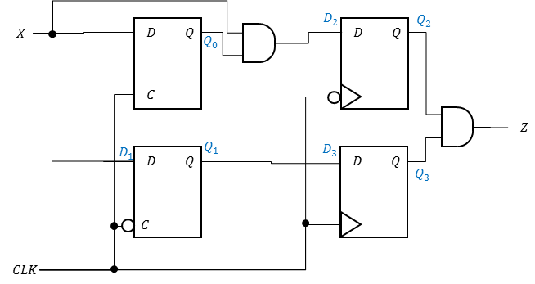
X
CLK
Q0
Q1=D3
D2
Q2
Q3
Z

